**HADOOP COMMAND DOCUMENT**

**hdfs dfs –ls <Directory path>**

**Above command used displays list of files and folders inside the directory**

**H dfs dfs -ls /user/mahantesh.kumbar**

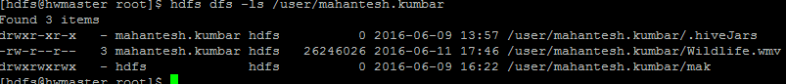

**hadf dfs –cat <hdfs file path>**

**Above command used to display the content of file**

**hdfs dfs -cat /user/mahantesh.kumbar/ba**



**hdfs dfs –put < local path> <hdfs path>**

**Above command used to coy data from local to hdfs**

**# hdfs dfs –put ba /user/mahantesh.kumbar**

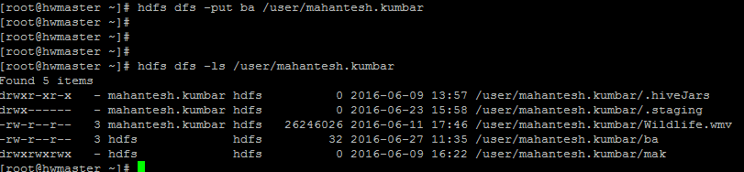

**hdfs dfs –get <hdfs path> <local path>**

**Above command used to copy data from hdfs to local**

**# hdfs dfs -get /user/mahantesh.kumbar/mak /home/mahantesh.kumbar**

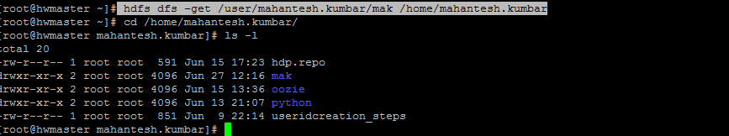

**hdfs dfs -du -s –h < directory or file path >**

**Above command used to check size of directory or file**

hdfs dfs -du -s -h /user/mahantesh.kumbar



**hdfs dfs –chmod 755 –R < Directory or file path >**

**Above command used to change permission (directory & file)**

**hdfs dfs -chmod 777 /user/mahantesh.kumbar/mak**

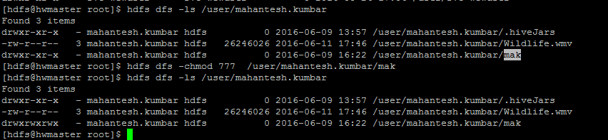

**hdfs dfs –chown –R user:group <Directory or file path>**

**Above command is used to change owner and group permission of directory or file**

**Hdfs dfs –chown –R hdfs:hdfs /user/mahantesh.kumbar/mak**

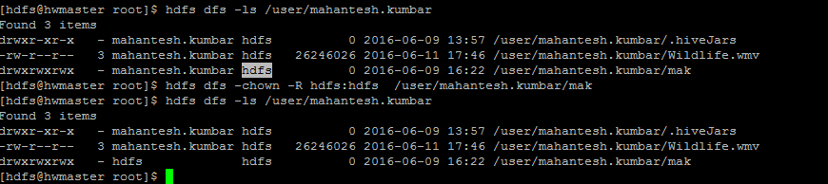

hdfs dfsadmin –safemode leave

**Above command is used to remove from Hadoop cluster from safe mode**

**# hdfs dfsadmin -safemode**



**# hdfs dfsadmin -safemode leave**



Expunge

**# hadoop fs -expunge**

**Above command is used for empty trash**



**hdfs dfsadmin –report**

**hdfs dfsamin –report command provides information about cluster**

**example : cluster size, DFS space, Decommission status**,

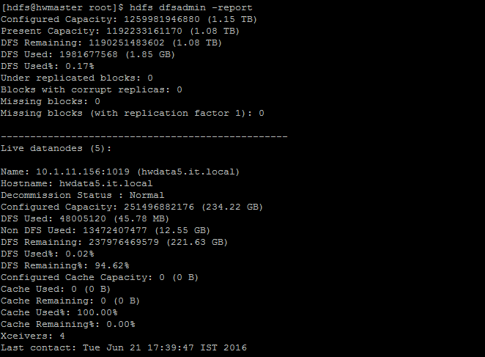

**mapred job –list**

**Above command is used for list the running map reduce jobs in cluster**

**#mapred job -list**



**Other options for mapred job commands**

1. **kill**

**To kill particular map reduce job use below command**

**cmd # mapred job –kill < job-id >**

1. **–status**

**To check status of map-reduce job use below command**

**mapred job -status < job-id >**

1. **logs**

**To check logs for particular job, use below command**

**mapred job –logs < job-id>**

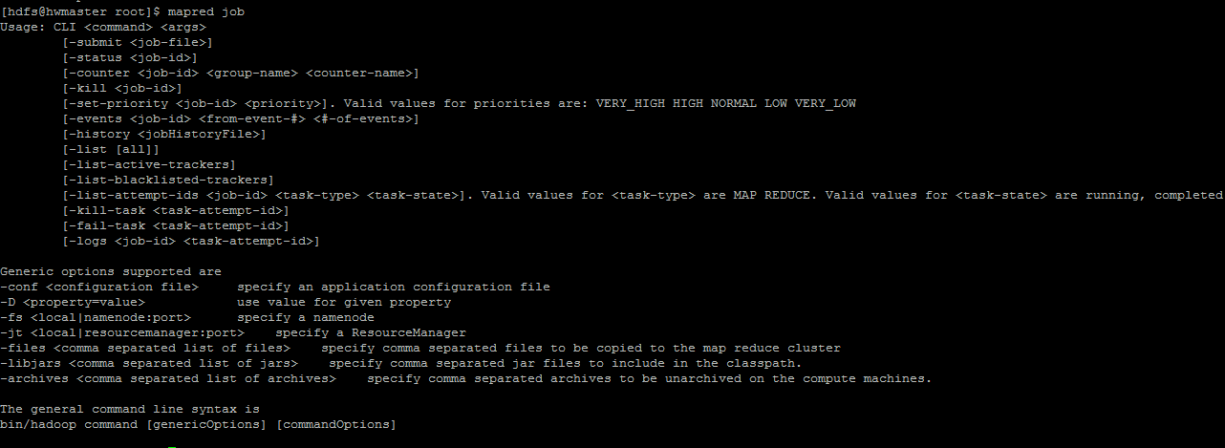

**KERBEROS COMMANDS**

**Kilst**

**Abvove command display key tab validity**

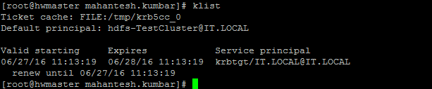

**TO CHECK KEYTABS path**

**cd /etc/security/keytabs/**

**[root@hwmaster keytabs]# ls -l**

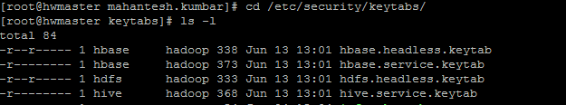

**klist -kt /etc/security/keytabs/mahantesh.kumbar.keytab**

**above command used for to keytab principals**

**# klist -kt /etc/security/keytabs/testuser.keytab**

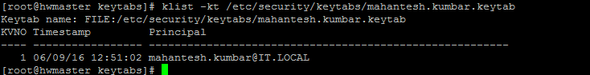

**Kinit –kt**

**Above command used to renew the keytabs**

**kinit -kt /etc/security/keytabs/mahantesh.kumbar.keytab** [**mahantesh.kumbar@IT.LOCAL**](mailto:mahantesh.kumbar@IT.LOCAL)

